KMSAuto Net Activator Guide

*KMS Auto Net is the activator of Microsoft Products such as Windows & Office. It offers you to activate any version of Windows from 7 to 10 without paying a penny to the Microsoft company.*

This activator doesn’t spam on your PC it activates your Windows in such a way that it makes it look like it’s the original copy of Windows.

Instead of only activating Windows, this excellent activator will help you in activating any version of Microsoft Office. No matter if your office version is 2003 or 2016, it will enable all the versions.

Even though this can help you in activating the latest version of MS Office, which is 365, no other activator provides such features that this cool tool gives you.

|  |  |
| --- | --- |
| Name | KMSAuto |
| Size | 5.0 MB |
| Version | 10.2.0 |
| Requires | Net Framework 4.0 |
| Developer | Team DAZ |
| Category | Activator |
| Updated | 1/1/2020 |
| Content Rating | 5 Stars |
| Installed | 600,000,000+ |
| Features | One Click |

**What Is KMS Auto Net?**

**Contents**  [show](https://official-kmspico.co/kmsauto-net-activator/)



*KMS AUTO*is not only a [Windows 10 Activator](https://official-kmspico.co/windows-10-activator/), but it is more than you expect about this. This is the multi-functional activator that provides you with many other features instead of just activating your windows.

**KMSAuto can be used to activate Microsoft Windows versions such as Windows 7, 8, 8.1, 10, etc. This means you don’t need to download and install different activators to install other versions.**

It can also be used in the activation of your Microsoft Office; you can activate MS office from 2006 to 2016, including **Office 365.**

The layout of this tool is immaculate you don’t need to have a professional guide for installing it or activating your Windows while using this.

This tool is 100% secure, and it is virus-free while other activators contain virus or trojans which damage your computer very badly. It is the reason why KMSAuto is most famous among individuals because it is effortless to use and very reliable.

**How KMSAuto Works**

KMSAuto works the same as the [Microsoft](https://www.microsoft.com/) KMS Server. The KMS means **Key Management Server,**which is used for big companies.

As you know that those companies have too many computers and buying a Windows copy for each computer & then activating it is a very much difficult task. So, this is why Bill Gates created this KMS server for those companies.

Whenever they update Windows, it automatically activated their machine without inserting the key.

It automatically discovers the KMS Server on the computer, which is connected to each other. KMSAuto also follows the same process to activate your Windows.

Whenever you activate your Windows, it connects to the KMS Server and then Windows think it is a real network. Instead of this, you can even install it by using the Keys.

The keys which KMSAuto provides you are always the latest keys that were used in activating your windows. Also, it activates the **MS Office** in just a few clicks.

**Key Features**

There are a lot of features that KMSAuto gives to its users. You must check all the features before installing it on your computer. So, this way you will learn what you are actually going to install & what this awesome activator provides you.

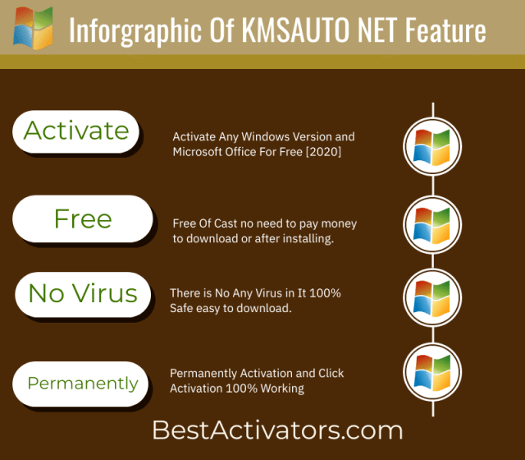

*Let’s now move to the features list:*

**Activate Windows**

This KMSAuto activator helps you in activating the Microsoft Windows OS freely. If you are one of them who don’t want to buy or don’t have enough money to get an original copy of Windows OS.

Then you must use this activator to activate your Windows. It gives you the original windows status which means when you connect your PC to the internet then it will show Microsoft that you are using the original copy.

Many other activators do the same but the problem is that they got caught and you will then be marked as a spammer, or sometimes they deactivate your Windows.

**Activate Microsoft Office**

If you are also using the MS Office on your computer and you have downloaded the backup from the third-party website instead of buying the original one?

And also, your trial is expired, but you still want to use it free without paying money. Then you must be pleased to listen that the KMSAuto also helps you in activating your Office.

It doesn’t matter if you are using a 2007 version or 2016. This activator activates all the version of MS Office even Office 365 can be activated using it.

This way, you can enjoy all the limited features of the office free until you reinstall your Windows or deleted your office.

**Activate Windows Using Keys**

If you are the one who doesn’t understand the KMS Server and wants to activate their Windows using a product key. Then you can also do that by using this software.

Now you don’t need to find the right keys for your Windows and waste your hours in searching on Google because there are so many websites, who claim that they give you the original keys, but they only give you worthless dummy keys.

KMSAuto automatically detects the Windows version and then gives you the right key within a few seconds. So, then you need to copy that key and enter it in Activate Windows Section, and you are done.

**No Advertisements**

This is one of the most valuable features which I love about KMSAuto Activator as it doesn’t contain any ads. I have used many activators but they contain too many annoying ads that disturb when activating Windows.

Now using this you can [activate your office](https://official-kmspico.co/activate-microsoft-office/) and Windows OS without getting disturbed by those advertisements.

**Backup Files**

It automatically backup the activation files so whenever you reinstall your Windows it will then install it without any further steps.

This great feature helps you when your windows suddenly got corrupted and you don’t have the file or not connected with the internet.

**Permanently Activate Windows**

If you have activated your windows using any other activator then you must be aware that they are not permanent & your windows automatically got deactivated.

But using this KMSAuto activator your Windows will be installed permanently. You don’t need to [activate windows](https://official-kmspico.co/how-to-activate-windows-10/) again and again after a specific time.

**100% Virus Free**

This activator is 100% secure and virus free. Don’t worry about the trojans or malware, it is malware proof. It’s checked by the **Virus Total** and is trusted by many users on the internet.

**System Requirements**

* It needs to have .NET Framework 4 Package installed on your computer.
* You need to log in as an Administrator otherwise it will not work.
* 5MB of your Hard Disk space is required to install.

**Have you just read the features of the KMSAuto Activator? Want to download the activator?**

**Download KMS Auto 2021**

Then let’s just move to the download link and also will teach you how to download KMSAuto by using our download link.

[**Download KMSAuto**](https://official-kmspico.co/download-kms-auto-net)

First of all, you need to click on the download button which is given Above. When you click on that you will then be redirected to our download page.

After that, you need to click on the download button which is located there & you then get the Mediafire link.

Now in the Mediafire just click on the **Download Now** & it will take few seconds and then the download will start automatically.

Downloading time varies on your internet speed. Don’t blame my download link Lol

**How To Install KMS Auto**

Installing KMSAuto is a little bit different than installing any ordinary software. Because it needs to have your antivirus disabled before proceeding to the installation process.

If you don’t **disable your antivirus or Windows Defender** then it will delete your KMSAuto. Don’t be afraid of viruses its secure 100% but the reason behind this is that Microsoft has **Blacklisted** it as it activates the Windows OS.

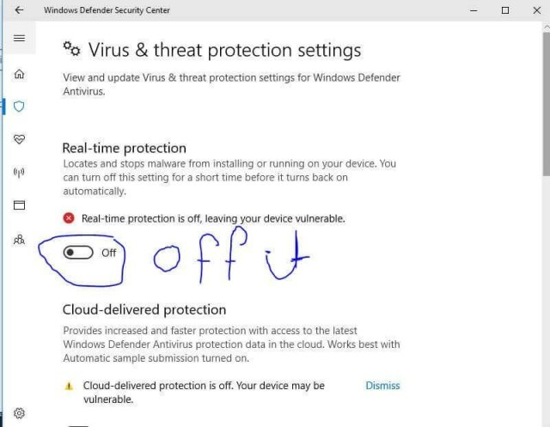

As you know that activating the Windows or any other software using third-party activator is piracy. This is why they have Blacklisted KMSAuto Activator.

Ok, enough talk now let’s move to the installation process.

* First of all, as I told you above you need to disable your antivirus or Windows Defender.
* Now extract the file and enter the password (You can find the password here).
* After extracting just double click on the icon and an installation window will appear.
* In that window follow all the steps and then KMSAuto will be installed on your computer.

**That’s all  Isn’t it easy**

Now here comes the main part of this article which is activating the MS Office and Windows using KMSAuto. Read the guideline below so you don’t make any mistakes while activating.

**How To Activate Windows Using KMS AUTO**

Activating Windows is not a very difficult task. It’s very easy and will not consume much time.

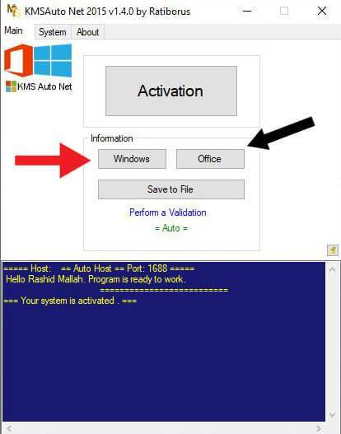

The process is as simple as eating (Lol Just Kidding :D)

Now before moving to the activating process first of all you need to restart your computer after installing KMSAuto.

After restarting again go to your Windows Defender and Disable **Real-Time Protection**(otherwise you will be unable to open KMSAuto).

After that Go to **Start Menu** and search for the **KMSAuto** there.

Now tap on the KMSAuto icon and a new Window of KMSAuto will appear on your screen.

There you will find many options you just need to click on the **Activate Windows** button.

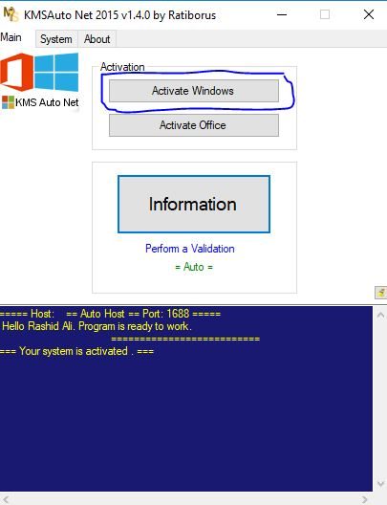

It will take a few seconds and you will then see a success message appear. After that message, close the KMSAuto and Restart your computer.

Now you just need to right-click on My Computer & click on Properties. There you can see your **Windows activation status**.

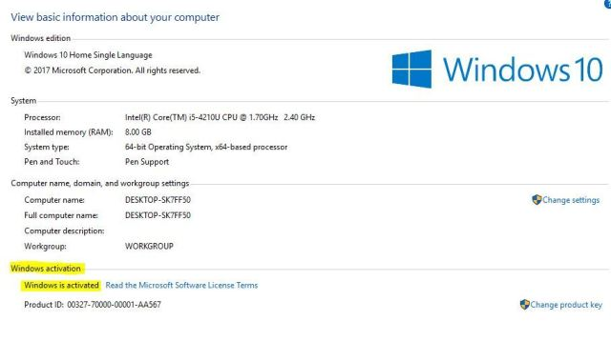

**How To Activate Microsoft Office**

After activating Microsoft Windows OS now it comes to the MS Office.

The activation process is almost the same. When you have activated windows then you need to restart the computer.

Now you again need to disable your **Real-Time Protection** in Windows Defender.

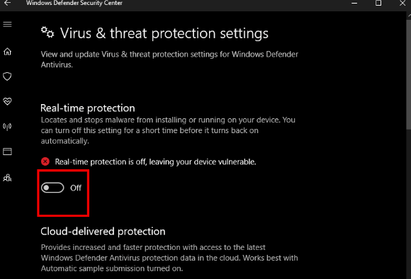

Again go to the Start Menu and Search for the KMSAuto, you will see it’s logo there just click on that.

Here you will see KMSAuto is opened on your Screen.

Now you first need to open any product of Office, for example, Word or Excel.

After this don’t minimize the Excel or Word just let it opened and then open the KMSAuto there.

Now you can see there is a button called **Activate Office.**Click on that button and you will have to wait for a few seconds.

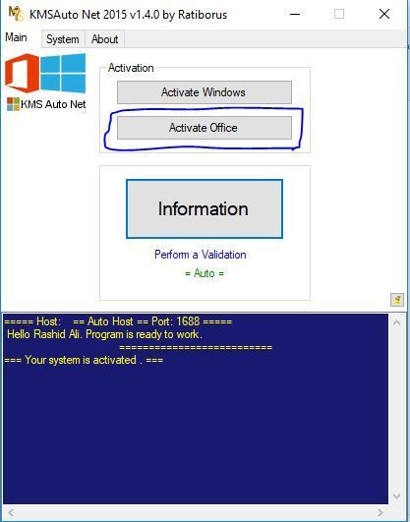

After you see the success message on your screen you need to restart your computer.

When you restart your computer now open Word and click on Files, here you will see there is a menu labelled Account click on that. There you will find out if your Office is activated or not.

If it’s still not activated then you should follow the same procedure again but carefully.

These are some most frequently asked questions that I have collected. You can check your Question here if you are unable to find your answer feel free to ask in a comment section.

I am always there to answer your question and help you. I will be very glad to hear from you

**Best Alternatives**

I hope you liked the KMSAuto Activator, but in some cases, you don’t like it or it fails to perform the work as you expected then you should move to the alternatives.

There are many alternatives to KMSAuto available on the internet but find the right is really a difficult task. For this, I have collected some most famous and the best KMSAuto activators alternatives.

These are also 100% and safe to use. You should check them one by one if the single activator doesn’t work for you.

*Let’s now check out the list of those alternatives:*

[**KMSPico**](https://official-kmspico.co/kmspico-download/)

KMSPico comes the first in our alternatives because this awesome activator never fails and you will never get upset when using it.

This is an automatic activation based software and works the same as KMSAuto do. It also follows the famous KMS Server method to activate your windows.

It is very light in size and very simple to use. The UI is very simple and beautiful anyone can understand it within a few seconds.

KMSPico gives you two ways to activate windows.

**#1 auto-activation:**

You read that right, this activator gives you an automatic activation feature. When you install [**KMSPico 11**](https://official-kmspico.co/download-kmspico-11-for-windows-7/) on your computer you can see there is an Auto KMS logo, just click on that logo and your windows will automatically be activated.

**#Manual Activation:**

Manual activation will help you in choosing which product you want to activate. If you don’t want to activate Office or Windows (or maybe you have that product already activated).

Then you can use this method to avoid files from being overwritten. This is also very useful in most cases.

Instead of this, there are still some cons of this activator. See the Pros & Cons list below to know what you will miss using this activator.

**Pros**

* Activates all versions of Windows 8, 8.1 & 10
* It can activate all the versions of Microsoft Office from 2003 to 365
* KMSPico also allows you to activate Windows Server
* It doesn’t require any internet connection
* 100% safe & secure
* Virus & Trojans Proof
* Very light in size
* Easy to use

**Cons**

* No option to Activate Windows 7
* It asks for administrator permission

[**Microsoft Toolkit**](https://official-kmspico.co/microsoft-toolkit-download/)

This is another activator of Microsoft Windows and Microsoft Office. The first name of Microsoft Toolkit was the EZ activator.

Microsoft Toolkit works on the principle of KMS Server which replaces its original files with the auto-generated files. This activator works on both processors of 32bit & 64bit respectively.

You can activate any version of Windows & Office the best thing is that it also supports Windows 7 activation. If you are still using Windows 7 then Microsoft Toolkit is the best option for you.

It will activate them permanently so you don’t face any problem and keep checking for the activation. Also, it provides you with the original keys which you can use to activate if you don’t want to use the KMS method.

This activator is also free and there are no annoying ads. It doesn’t require you have an internet connection this works totally standalone.

Microsoft Toolkit doesn’t only helps you in activating Windows but this also helps you to activate Windows Server as well.

*Let’s now check out the Pros & Cons of this alternative:*

**Pros**

* Activates All version of Windows (Including Windows 7)
* It helps you in activating all version of MS Office
* Your windows & office will be activated permanently
* Microsoft Toolkit guarantees you for the Genuine Activation

**Cons**

* Administrator Privileges are required to run this activator
* Needs to disable Anti-Virus before installing

[**Windows Loader**](https://official-kmspico.co/windows-loader-download/)

Windows Loader is also Known as the Windows 7 loader. This alternative helps you in activating all the versions of Windows 7. It is developed by Team Daz.

Team Daz is the most famous for developing such activators, if you are an old user of these activators then you must have listened to this name somewhere.

This activator has two methods to activate your windows the first one is automatic and the other is by generating custom keys. You can choose between these two methods for activation.

It supports Virtual Machines as well. Also, the best thing is that it supports almost all languages. So, if you are using Windows in any other language then Windows Loader is one of the best options for you.

It has the trial reset feature which helps you to reset the trial when it expires. It’s very useful when you don’t want to use the third-party activator or you are afraid if your pc gets damaged.

Windows Loader is totally free of cost and is Ads free tool.

*Let’s check out the Pros & Cons of Windows 7 Loader:*

**Pros**

* Automatically Detects Your System Information
* Activate Windows 7 OS
* Generate Genuine Keys For Manual Activation
* Auto Activation Feature
* Trial Reset Feature
* Bypass the Genuine Windows Verification
* Supports Multiple Languages

**Cons**

* It only activates Microsoft Windows
* Maybe it contains bugs because it is not updated for a long time

These are some of the best and the most useful Windows Activator. I have checked all these alternatives that’s why I am sharing them with you. By using the above alternative or the KMSAuto you will then be able to activate your windows permanently without paying a penny.

**Conclusion**

This is the brief and complete Guide for the **KMSAuto Activator**. You must check this activator as it is the best option and the best activator for windows and office.

Also, I have shared some most of the best alternatives of the KMSAuto which you must check out. These activators are the best in their own way.

Have you missed the feature list? Then you must check out otherwise you will not understand what this tool gives you. Also, I have mentioned the step by step Installation guide above if you have skipped it then please have a look at this.

So, you don’t make any mistakes while installing. These are the best ways to activate your Microsoft Products without paying money.